

**Secondary 3 Elementary Mathematics Performance Task**

**Instructions to students:**

* This is a group task. Each group consists of 3 to 4 members.
* Issued on **29 March 2021, Monday**.
* Deadline: **Google document has to be submitted to your Mathematics teacher by 16 April 2021, Friday 1430 hours. Make a copy of this document and name it as 2021 Sec 3 EM PT_Group#_S3-0#. Give your teacher the rights to comment.**
* There are 6 parts to this task: Part 1A, Part 1B, Part 2A, Part 2B Part 3A and Part 3B .

Refer to the instructions in each part and complete the parts.

* There will be a penalty for late-submission. Students who submit the task within 7-days (inclusive of the 7th day) after the deadline will be awarded 50% of the marks scored. A zero mark will be given if the task is submitted beyond 7 days after the deadline. Students are also expected to complete and submit the task even after 7 days of the deadline.

|  |
| --- |
| **Declaration and statement of authorship:** |
| 1. This assignment is our original work and no part of it has been copied from any other student’s work or from any other source except where due acknowledgment is made. 2. We understand that plagiarism is the presentation of the work, idea or creation of another person as though it is my own. It is a form of cheating and is a very serious academic offence. Plagiarised material can be drawn from, and presented in, written, graphic and visual form, including electronic data, and oral presentations. Plagiarism occurs when the origin of the material used is not appropriately cited. |

|  |  |
| --- | --- |
| **Class** |  |
| **Group Members**  **(Name and Index No.)** |  |
|  |
|  |
|  |
| **Date of Submission** |  |

**LEARNING OBJECTIVES**

Students will be able to

* describe the key characteristics of the graphs of exponential functions,
* apply mathematical methodologies to real-world problems,
* recognise and appreciate the connections between theory and applications.

**CHECKPOINTS**

|  |  |
| --- | --- |
| **Date** | **Task(s) to be completed** |
| 29 March 2021  (Monday) | Issue performance task (PT) to the whole level in Google Classroom. |
| 29 March 2021 (Monday) | E Math teacher goes through the PT Part 1 (Pre-task) with class.  E Math teacher briefs students about the PT in class.  E Math teacher splits class into groups allocated by form teacher. |
| 5 April 2021 (Monday) | Group submits Script for Video of Part 2 to E Math teacher for feedback. |
| 9 April 2021 (Friday) | E Math teacher gives feedback to the script of each group before Video is produced.  Group discussion during 1 E Math lesson. |
| 16 April 2021 (Friday)  1430 hours | Group submits final completed Video, Personal Reflection and Peer Evaluation. |

**GRADING AND EVALUATION**

*For official use by Math teachers only*

|  |  |  |
| --- | --- | --- |
| **Marks** (For Official Use) | | |
| **Part 1:**  **(Part 1A**  **Part 1B)** | Pre-task | **No marks.**  **To complete as the teacher goes through in class.** |
| **TOTAL**  **(Part 2A: Script)** |  | **/ 6** |
| **TOTAL  (Part 2B: Video)** |  | **/ 9** |
| **TOTAL**  **(Part 3**  **Part 3A: Personal Reflection**  **Part 3B: Peer Evaluation)** |  | **/ 5** |
| **TOTAL** |  | **/ 20** |
| **COMMENTS (if any)** |  | |

**Introduction: Mathematical Modelling**

**Introduction To Mathematical Modelling**

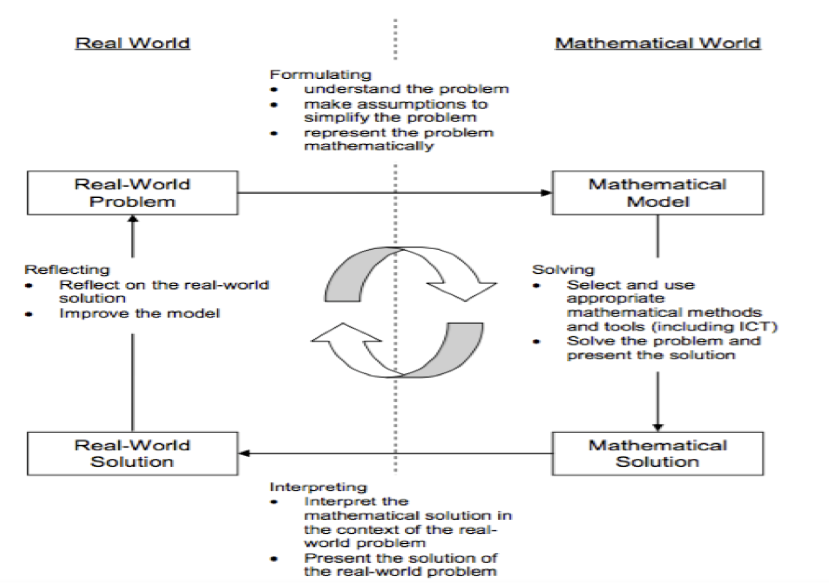

Mathematical modelling[1] is a process of representing real world problems in mathematical terms in an attempt to find solutions to the problems. It often involves creating an abstract model using mathematical language to describe the behaviour of a system that is occurring in real life. Watch these [videos on mathematical modelling](http://mathmodelling.sg/what.html).

**Recap: Key Features of Graphs**

Recall the key features of a graph:

**S**hape

**T**urning points and/or point of inflexion (Stationary points)

**A**symptotes

**I**ntercepts: axial intercepts

**R**egion: Domain, Range

**S**ymmetry: line of symmetry, rotational symmetry

**Notes:**

Stationary points are points on the graph where the gradient is zero.

Turning points (maximum point or minimum point) are stationary points.

But not all stationary points are turning points.

Domainrefers to the range of possible values of the independent variable, usually *x*.

Range refers to the range of possible resulting values of the dependent variable, usually *y*, after substituting the domain.

**Part 1A: Pre-Task- Exponential Functions**

Recall the graph of exponential functions *y* = *ax*, where *a* > 0 and a ≠ 1.

Watch this video [[HERE]](https://www.youtube.com/watch?v=1_SwKG4Zt60) to have a better understanding of the behaviour of exponential functions as compared to other functions

.

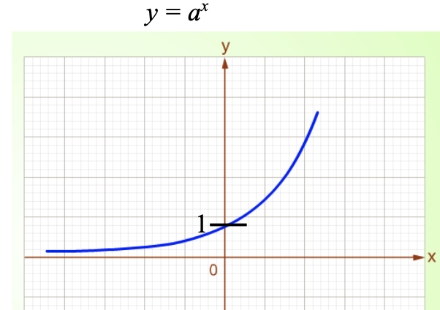

The most common exponential function is y equals e super x . ‘*e*’ here refers to the Euler’s number (Google “Euler’s number” if you are unsure of the constant value).

By changing the value of base *a* and the constant *k* in the function *y* = *kax* in this [Desmos link](https://www.desmos.com/calculator/b8ndkfhmqg), observe how the shape of the graph of exponential functions changes as the values of *a* and *k* change.

**Part 1B: Pre-Task**

Before you embark on the Performance Task, you will go through this pre-task with your teacher.

Take some time to watch a couple of videos that bring the exponential function to life.

[**EXPONENTIAL GROWTH EXPERIMENT - CHRIS BISHOP**](https://www.youtube.com/watch?v=DjlEJNfsOKc)

[**EXPONENTIAL GROWTH - M & Ms**](https://www.youtube.com/watch?v=qfYQUUC3F5I)

[**EXPONENTIAL GROWTH - ZOMBIES**](https://www.youtube.com/watch?v=EBuk4WbQX4g&t=30s)

[**EXPONENTIAL GROWTH - STUDENT POPULATION**](https://www.youtube.com/watch?v=1_SwKG4Zt60&t=34s)

Try modelling this set of data with your teacher now! 😀

**[Population Growth]**

An experimental population of fruit flies increases such that, after *t* days, the estimated number of fruit flies is represented by *N*.

|  |  |
| --- | --- |
| ***t* days** | ***N* number of flies** |
| 0 | 100 |
| 1 | 165 |
| 2 | 272 |
| 3 | 449 |
| 4 | 741 |
| 5 | 1223 |
| 6 | 2018 |
| 7 | 3330 |
| 8 | 5494 |
| 9 | 9065 |
| 10 | 14 957 |

Model the above data using an appropriate exponential function.

You may do it with the help of a graphing software. However, you should also know how the mathematical model can be found without using a graphing software.

Using your mathematical model,

1. find the estimated number of fruit flies after 13 days,
2. *[Optional: This is A.Math]*

Find the value of *t* when the population reaches 20 000.

**Your modelling process and solution:**

Now that you have completed the pre-task with your teacher, start on the performance task.

**Part 2: Performance Task - Understanding the Context**

Before you embark on the Performance Task, watch the following videos to understand why and how the number of COVID cases increases.

1. [**How coronavirus spreads outdoors vs indoors?**](https://youtu.be/n6QwnzbRUyA)
2. [**How deadly is Covid19?**](https://youtu.be/2qdd7kirwIk)

**LEARNING GOAL**

To understand how the number of COVID cases would increase without safety measures by mapping the number of COVID cases as an exponential function. Students are to **decide** **on an appropriate exponential function** to map and **predict** the number of COVID cases if no measures are taken.

**ROLE**

You are a team of **youth ambassadors** who want to educate the public, in particular, students, about the importance of mandatory mask wearing and Safe Measurement Measures (SMM) in curbing the spread of the COVID19 virus.

**AUDIENCE**

Your audience are the students of the school.

**SITUATION**

As seen in the news, there are still members of the public who are still not wearing masks or adhering to the Safe Measurement Measures (SMM).

[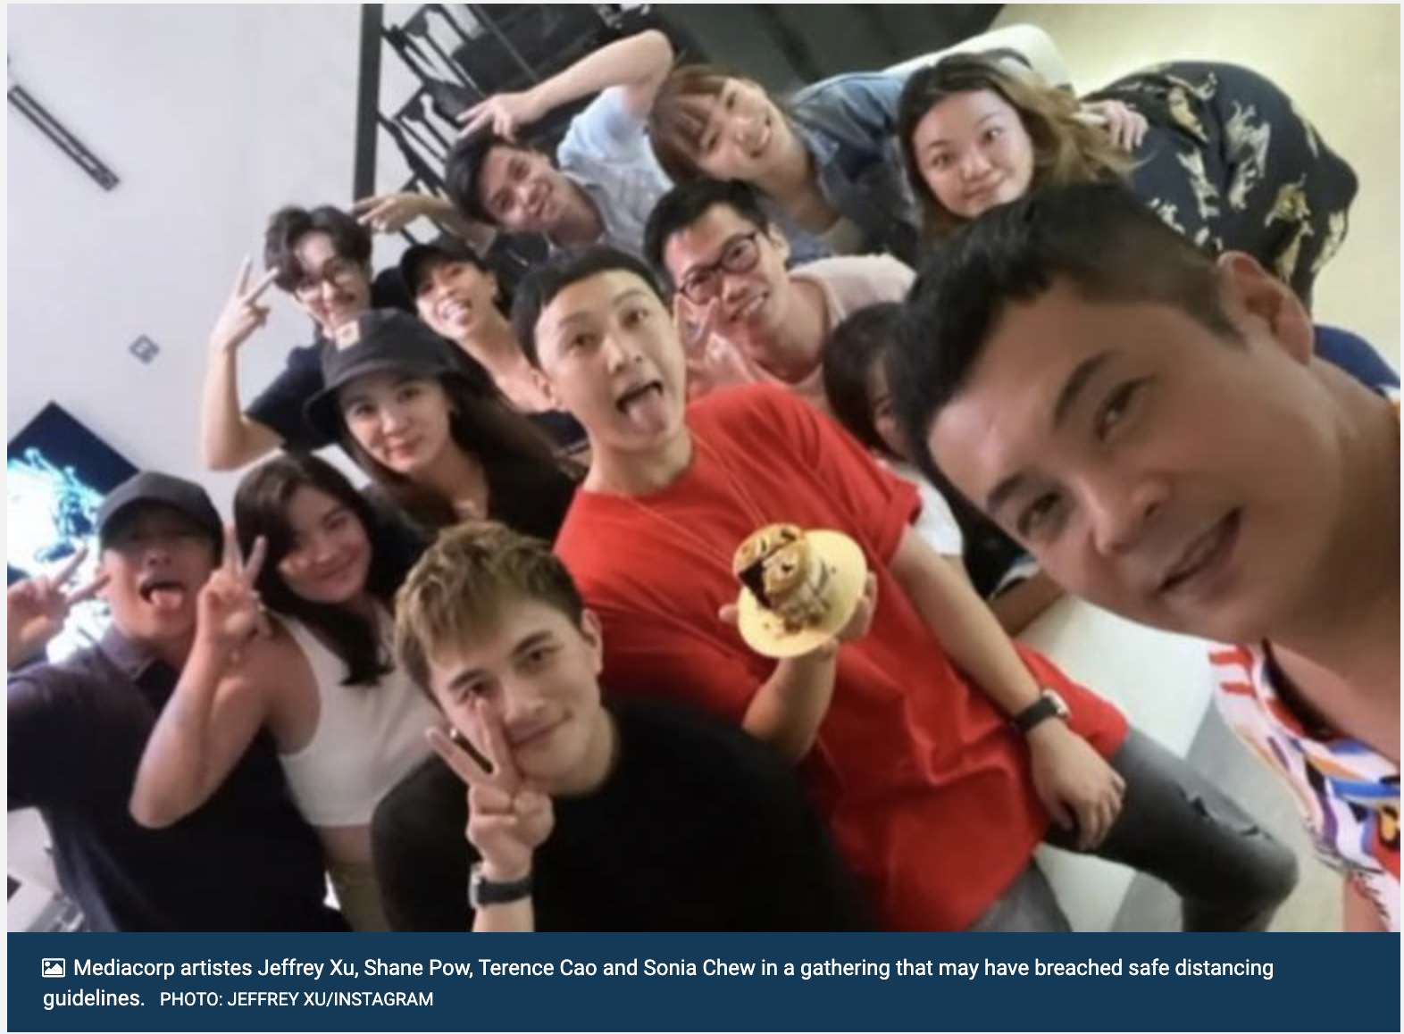](https://www.tnp.sg/news/singapore/more-celebs-may-be-trouble-over-large-gathering-private-home)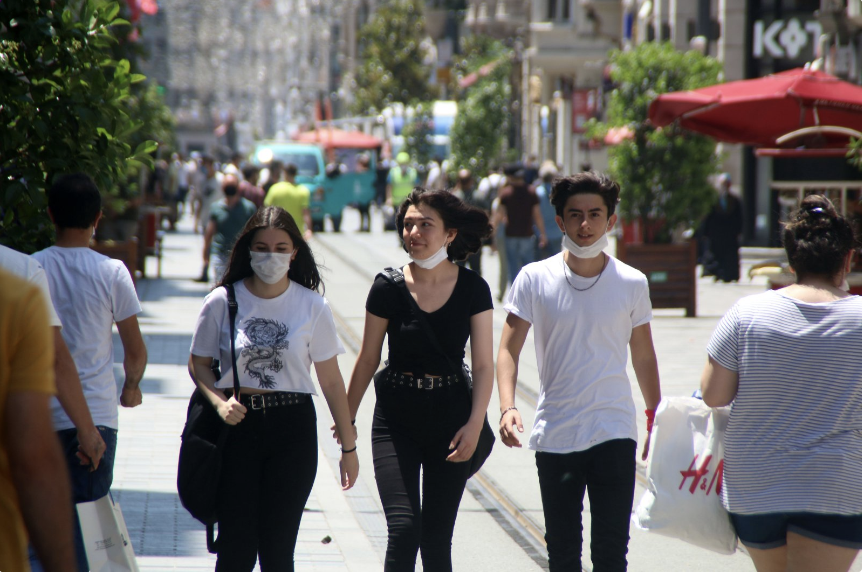

**MATH TASK**

Your task is to educate students of your school to have a greater awareness of the importance of wearing masks and following SMM so that they can influence their family members to do so as well. You are to approach this **mathematically** by modelling the number of infected cases in Singapore and up to two other countries using an exponential function. For instance, you can use the function, $y=ka^{t}$ or $y=ke^{t}$, in your explanation and presentation.

***Part 2A: Script for Video:***

Your team is to present your findings and research in the form of a script for your video. You have to provide the following:

(i) Sources for the data sets chosen

(ii) State clearly the independent and dependent variables

(iii) Explain the process of how the exponential function is obtained, including any assumptions made

(iv) Show how you model the function using a graphing software

(v) Provide comparisons between the exponential functions of the countries chosen

***Part 2B: Video:***

Your team is to present your findings and research in the form of a **video**. In your video, you are to show, using the exponential function, the impact and the potential outcome of the number of COVID cases for Singapore and other countries if measures such as the mandatory wearing of masks and SMM are not implemented to curb the spread of the virus.

Your group is required to produce a **3-minute** **video**, to explain about your findings using appropriate reasonings, mathematical expressions and symbols.

*Refer to rubrics shown on the next page.*

**Instructions:**

* You may use a suitable graphing software to augment your explanation.
* Restrict the video to a maximum of 3 minutes.
* Name/Label the video **“2021 Sec 3 EM PT Part 2_Group#_S3-0#”**
* Upload on Google Drive
* Give your teacher the rights to comment on your video.
* Copy and Paste Link into the Google Document below:

**Our Group Video Link:**

|  |  |
| --- | --- |
| **<Insert link>** | **[15]** |

**Please refer to the rubrics shown on the next page.**

**Part 2 Scoring Rubrics**

|  |  |  |  |  |
| --- | --- | --- | --- | --- |
| **Performance Task (Part 2A - Script)**  **Scoring Rubrics [6 marks]** | | | | |
| **Criteria** | **3 Excellent** | **2 Proficient** | **1 Adequate** | **0 Limited** |
| 1. **Model Formulation: Identify variables and assumptions** | Suggest an exponential model for the number of COVID cases  Identify independent and dependent variables, and constants that are essential to the problem.    Variables used are properly defined with appropriate symbols assigned.    Identify assumptions that are valid and comprehensive in simplifying the problem. | Suggest an exponential model for the number of COVID cases  Identify independent and dependent variables, and constants that are relevant to the problem.    Variables used are properly defined with appropriate symbols assigned.    Identify assumptions that are valid and appropriate in simplifying the problem. | Suggest an exponential model for the number of COVID cases  Identify independent and dependent variables that are relevant to the problem.    Variables used are not properly defined or do not have appropriate symbols assigned.    Identify assumptions that are either invalid or do not aid in simplifying the problem. | Not able to suggest any exponential model for the number of COVID cases |
| 1. **Model Solution: Develop a model and make conclusions** | Variables used are properly defined with appropriate symbols assigned.  The data analysis is well-organised and shows the proposed function relating the variables.  Assumptions are valid and comprehensive in simplifying the problem. | Variables used are properly defined with appropriate symbols assigned.  The data analysis is organised and shows the proposed function relating the variables.    Assumptions are valid and appropriate in simplifying the problem. | Variables used are not properly defined or do not have appropriate symbols assigned.  The data analysis is organised.  Assumptions are either invalid or do not aid in simplifying the problem. | Variables are irrelevant to the problem.    Did not identify assumptions to simplify the problem.  The data analysis is not organised.    The progression to the function is not seen. |

|  |  |  |  |  |
| --- | --- | --- | --- | --- |
| **Performance Task (Part 2B - Video)**  **Scoring Rubrics [9 marks]** | | | | |
| **Criteria** | **3 Excellent** | **2 Proficient** | **1 Adequate** | **0 Limited** |
| 1. **Information organisation and analysis**   **Note: -1 mark if video exceeds 3 mins limit.** | Presentation of information and function includes all headings, units, and is organised in a way that is easy to understand and analyse.    Comparing the number of infected cases in Singapore with 2 appropriate countries using an exponential function.  Analysis, explanation and reasonings are detailed, clear and logical.  Video was clear in delivery (visual and audio).  Subtitle is coherent and aligned to presentation. | Presentation of information and function includes most headings, units, and is organised in a way that is easy to understand and analyse.  Comparing the number of infected cases in Singapore with 1 other appropriate country using an exponential function.    Analysis, explanation and reasonings are mostly clear and logical.  Video was clear in delivery (visual and audio).  Subtitle is coherent and aligned to presentation. | Presentation of information and function lacks headings and units and is organised in a way that is difficult to understand and analyse.  Comparing the number of infected cases in Singapore with 1 other country using an exponential function.    Analysis, explanation and reasonings are brief.  Video was clear in delivery (visual and audio).  Subtitle is coherent and aligned to presentation. | The information and function are not organised    The information and function is incomplete or not sufficient.  No comparison of the number of infected cases in Singapore with another country.  Analysis, explanation and reasonings are unclear, illogical and disorganised.  Video was unclear in delivery (visual and audio)  Subtitle is not coherent or aligned to presentation. |
| 1. **Model Solution: Graphical solution** | Use appropriate graphing software to present graphical solution. The link to the graph is included.    The image of the graphical solution is presented with the function.    The graph image included all headings, units, and data in an organised way that is easy to understand and analyse.    The graphical solution is logical in the context of the problem. | Use appropriate graphing software to present graphical solution. The link to the graph is included.    The image of the graphical solution is presented with the function.    The graph image included most headings, units, and data in an organised way that is easy to understand and analyse.    Some parts of the graphical solution are not logical in the context of the problem. | Use appropriate graphing software to present graphical solution. The link to the graph is included.    The image of the graphical solution presented does not include the function.    The graph image is lacking headings, units, and data and is difficult to understand and analyse.    The graphical solution is not logical in the context of the problem. | Did not use graphing software to present graphical solution. |
| 1. **Model Solution: Develop a model and make conclusions** | Variables used are properly defined with appropriate symbols assigned.  The data analysis is well-organised and shows the proposed function relating the variables.  Assumptions are valid and comprehensive in simplifying the problem.  The progression to the function is clear and coherent.    The conclusion demonstrates purposeful coherence and includes a well-executed progression of ideas, making it easy to comprehend. | Variables used are properly defined with appropriate symbols assigned.  The data analysis is organised and shows the proposed function relating the variables.    Assumptions are valid and appropriate in simplifying the problem.  The progression to the function is sufficient.    The conclusion demonstrates coherence and includes a well-executed progression of ideas, making it easy to comprehend. | Variables used are not properly defined or do not have appropriate symbols assigned.  The data analysis is organised.  Assumptions are either invalid or do not aid in simplifying the problem.  The progression to the function is not seen clearly.    The conclusion demonstrates limited coherence, clarity and cohesion, making it hard to comprehend. | Variables are irrelevant to the problem.    Did not identify assumptions to simplify the problem.  The data analysis is not organised.    The progression to the function is not seen.    The conclusion demonstrates a lack of coherence, clarity and not supported by any data. |

**Part 3: Personal Reflection & Peer Evaluation**

**(A)** Each student is to submit a Personal Reflection Google Form of their learning experience in this Performance Task.

Your personal reflection should address the following points or questions:

1. How has the task helped you to gain a deeper understanding of the topic, Functions and Graphs?

2. How has the learning experience enabled you to extend your knowledge to other topics or real-world applications?

3. Provide relevant evidence or examples to illustrate your points in (1) and (2).

**(B)** Each student is to refer to the Peer Evaluation Rubric on P.15 and complete the Peer Evaluation Google Form for **two other members** in the group. Each student should not evaluate more than 2 students or himself/ herself.

**Part 3A: Personal Reflection**

**Part 3A - Personal Reflection Scoring Rubric**

|  |  |  |  |  |
| --- | --- | --- | --- | --- |
| **Personal Reflection (Part 3A)**  **Scoring Rubrics [3 marks]** | | | | |
| **Criteria** | **3 Excellent** | **2 Proficient** | **1 Adequate** | **0 Limited** |
| **Personal Reflection** | Response demonstrates an in-depth reflection on the mathematical concepts, and/or strategies presented.    Viewpoints and interpretations are insightful and well supported. Clear, detailed examples are provided, as applicable. | Response demonstrates a general reflection on the mathematical concepts, and/or strategies presented.  Viewpoints and interpretations are supported. Appropriate examples are provided, as applicable. | Response demonstrates a minimal reflection on the mathematical concepts, and/or strategies presented.    Viewpoints and interpretations are unsupported or supported with flawed arguments. Examples, when applicable, are not provided or are irrelevant. | Response demonstrates a lack of reflection on the mathematical concepts, and/or strategies presented.    Viewpoints and interpretations are missing, inappropriate, and/or unsupported. Examples, when applicable, are not provided. |

**Part 3B: Peer Evaluation**

**Part 3B - Peer Evaluation Scoring Rubric**

|  |  |  |  |
| --- | --- | --- | --- |
| **Peer Evaluation (Part 3B)**  **Scoring Rubrics [2 marks]** | | | |
| **Criteria** | **2 Excellent** | **1 Adequate** | **0 Limited** |
| **Contributions & Attitude** | Always cooperative. Routinely offers useful ideas. Always displays a positive attitude. | Sometimes cooperative. Sometimes offers useful ideas. Rarely displays a positive attitude. | Never cooperative. Rarely offers useful ideas. Is disruptive. |
| **Cooperation with Others** | Did more than others. Highly productive. Works extremely well with others. | Does not cause problems in the group. Focuses on the task most of the time. Can count on this person. | Did not do any work. Does not contribute. Does not work well with others. |
| **Focus, Commitments** | Tries to keep people working together. Almost always focused on the task. Is very self-directed. | Sometimes focuses on the task. Not always a good team member. Must be prodded and reminded to keep on task. | Often is not a good team member. Does not focus on the task. Lets others do the work. |
| **Team Role Fulfillment** | Participates in all group meetings. Assumes leadership role. Does the work that is assigned by the group. | Participates in some group meetings. Provides some leadership. Does some of the work assigned by the group. | Participates in few or no group meetings. Provides no leadership. Does little or no work assigned by the group. |
| **Ability to Communicate** | Always listens to, shares with, and supports the efforts of others. Provides effective feedback. Relays a lot of relevant information. | Often listens to, shares with, and supports the efforts of others. Usually does most of the talking. Rarely listens to others. Provides little feedback. Relays very little information that relates to the topic. | Rarely listens to, shares with, or supports the efforts of others. Is always talking and never listens to others. Provides no feedback. Does not relay any information to teammates. |

*Adapted from* [*https://teaching.cornell.edu/resource/group-work-how-evaluate-it*](https://teaching.cornell.edu/resource/group-work-how-evaluate-it)

**Helpful Resources**

Here are some helpful resources to prepare this lesson in Part 3.

Desmos:

1. [Regression curve fitting in Desmos](https://www.youtube.com/watch?v=5rMRYGiPb0M)

2. [Other Desmos resources](https://learn.desmos.com/)

Google Sheets:

1. [Graphs in Google Sheets](https://support.google.com/docs/answer/63824?co=GENIE.Platform%3DDesktop&hl=en)

2. [Scatter plots and best-fit line in Google Sheets](https://usingtechnologybetter.com/the-line-of-best-fit-and-scatterplots-in-google-sheets/)

3. [Scatter plots in Google Sheets](https://support.google.com/docs/answer/9143294)

4. [Trendlines in Google Sheets](https://service.goshen.edu/support/index.php?/default_import/Knowledgebase/Article/View/974/0/add-a-trendline-to-a-chart-in-google-sheets)

4. [Equations in Google Sheets](https://support.google.com/docs/answer/6075154)

GeoGebra:

1. [Regression curve fitting in GeoGebra](https://docs.google.com/document/d/1GO3CLhGPXCv0ab4U0hUEaD0TGS-nacc3WDWAsNbP3oM/edit)

Congratulations! =)

You have completed the Performance Task.

Now you are ready to teach your students.

1. https://www.mathsisfun.com/algebra/mathematical-models.html